PROGRESS DOCUMENT
Predictive Modelling of mAb Fucosylation in CHO Cell Bioprocessing

Dataset Size Experiment: N=500 vs N=10,000

Models: Ridge | PLSR | Random Forest | ANN | GPR | Hybrid | XGBoost+SHAP

BMS Project — MSc Bioprocessing
Team Data Minds by Pranav, Sanjith

1. Project Overview
This document summarises progress on the BMS fucosylation prediction project. We built a pipeline of 7 models to predict monoclonal antibody (mAb) fucosylation from CHO cell culture conditions, run in two phases:
Experiment 1 (BMS1): 500 samples — typical small-scale bioprocessing dataset.
Experiment 2 (BMS2): 10,000 samples — tests whether more data improves model performance, particularly for the ANN.
The synthetic dataset is mechanistically grounded. Each variable and its relationship to fucosylation is based on published biochemistry (Raju et al. 2000, Hossler et al. 2009, Jedrzejewski et al. 2014). It includes batch effects, measurement noise, missing data variants, and a time-series component.

2. Dataset Summary
Property | BMS1 (N=500) | BMS2 (N=10,000)
Samples | 500 | 10,000
Features | 10 | 10
Batches | 10 | 50
Target Mean | 87.5% | 88.0%
Target Std | 5.59% | 5.73%
Train / Test | 400 / 100 | 8,000 / 2,000

Both datasets use identical ground truth equations, noise levels, and variable ranges. The only change is sample count and proportional batch scaling — isolating dataset size as the single experimental variable.

3. Experiment 1 — BMS1 (N=500)

3.1 Model-by-Model Summary

Ridge & PLSR (Linear Baselines)
Ridge achieved R²=0.51 with full coefficient interpretability. PLSR identified 3 significant features via VIP scores: GDP-Fucose (1.92), Temperature (1.76), and Mn (1.20). Both models are limited by their inability to capture nonlinear relationships (pH quadratic, saturation effects).

Random Forest
RF captured nonlinear effects and achieved R²=0.66. Feature importance was assessed via both MDI and permutation importance (Spearman ρ=0.96). Top features — GDP-Fucose, Temperature, pH — are consistent across all models. OOB score of 0.72 confirms reasonable generalisation.

ANN (Artificial Neural Network)
The ANN completely failed at N=500, producing R²=0.05. With 12,225 parameters trained on only 340 samples, the model was massively overparameterised. LIME explanations were generated but cannot compensate for poor predictions — interpretability does not fix a broken model.

GPR (Gaussian Process Regression)
GPR was the best performer at N=500 with R²=0.75. RBF kernel selected as optimal. Calibration was excellent (mean error 0.83%), 95% CI coverage was exactly 95.0%. High-confidence predictions (low σ) achieved R²=0.76 vs R²=0.44 for low-confidence — validating that uncertainty estimates are meaningful.

Hybrid (Physics-Informed)
Five biologically motivated features were engineered: FPI (substrate×cofactor), Energy Charge, Golgi Proxy, Stress Index, and Enzyme Activity. The hybrid model reached R²=0.72, a +4.9% improvement over raw features alone. Engineered features alone captured 64.7% of hybrid performance with just 5 features vs 10 raw.

XGBoost + SHAP
XGBoost achieved R²=0.74 with full SHAP explainability. Feature rankings matched biology: GDP-Fucose and Temperature as top drivers, correct directional effects. Feature interaction analysis detected GDP-Fucose×Mn synergy, consistent with ground truth.

3.2 Performance Summary — BMS1
Model | R² Train | R² Test | RMSE | MAE | Interp. | Uncert.
Ridge | 0.63 | 0.51 | 3.44 | 2.85 | 5/5 | 2/5
PLSR | 0.63 | 0.51 | 3.45 | 2.85 | 5/5 | 2/5
Random Forest | 0.96 | 0.66 | 3.04 | 2.28 | 3/5 | 3/5
XGBoost | 1.00 | 0.74 | 2.82 | 2.16 | 4/5 | 2/5
GPR | 0.87 | 0.75 | 2.47 | 1.97 | 3/5 | 5/5
ANN | 0.91 | 0.05 | 4.80 | 3.68 | 2/5 | 1/5

3.3 Multi-Criteria Comparison — BMS1
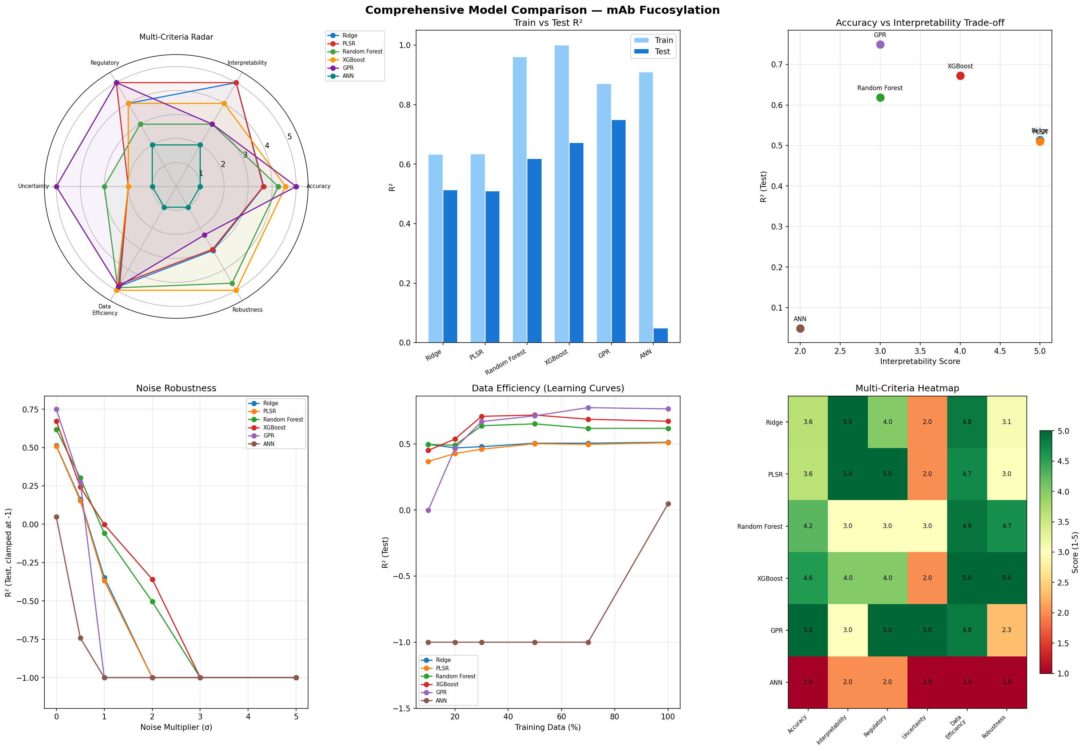
Figure 1: BMS1 (N=500) — Radar chart, R² comparison, noise robustness, learning curves, rubric heatmap.

4. Experiment 2 — BMS2 (N=10,000)

4.1 Key Changes
Only 3 values were changed: N_SAMPLES (500→10,000), N_BATCHES (10→50), N_BATCHES_TS (20→100). Everything else — ground truth, noise, relationships — remained identical. This isolates dataset size as the sole variable.

4.2 Model-by-Model Summary

Ridge & PLSR
Minimal improvement (0.51→0.57). These models were already at their structural ceiling — they cannot model nonlinearity regardless of data volume.

Random Forest
Improved from R²=0.66 to 0.79 (+20%). More data helped the trees find better split points for quadratic pH and temperature effects.

ANN
The headline result: R²=0.05 → 0.77 (+1440%). With 6,800 training samples vs 12,225 parameters, the model finally had enough data. LIME now shows coherent feature attributions matching biology.

GPR
Modest improvement (0.75→0.79, +5%). Still limited to 300 subsampled training points due to O(n³) scaling. Its strong RBF kernel prior was already sufficient at N=500.

XGBoost + SHAP
Best overall at N=10,000 with R²=0.83. SHAP analysis remained consistent. Now the best model on the rubric (Total: 24.09).

Hybrid Model
Raw features alone reached R²=0.82, leaving minimal room for physics improvement (+0.01%). The 5 engineered features still captured 74.7% of full performance — demonstrating domain knowledge value for dimensionality reduction.

4.3 Performance Summary — BMS2
Model | R² Train | R² Test | RMSE | MAE | Interp. | Uncert.
Ridge | 0.57 | 0.57 | 3.76 | 3.05 | 5/5 | 2/5
PLSR | 0.57 | 0.57 | 3.76 | 3.05 | 5/5 | 2/5
Random Forest | 0.96 | 0.79 | 2.66 | 2.14 | 3/5 | 3/5
XGBoost | 0.93 | 0.83 | 2.47 | 1.96 | 4/5 | 2/5
GPR | 0.79 | 0.79 | 2.61 | 2.09 | 3/5 | 5/5
ANN | 0.85 | 0.77 | 2.74 | 2.20 | 2/5 | 1/5

4.4 Multi-Criteria Comparison — BMS2
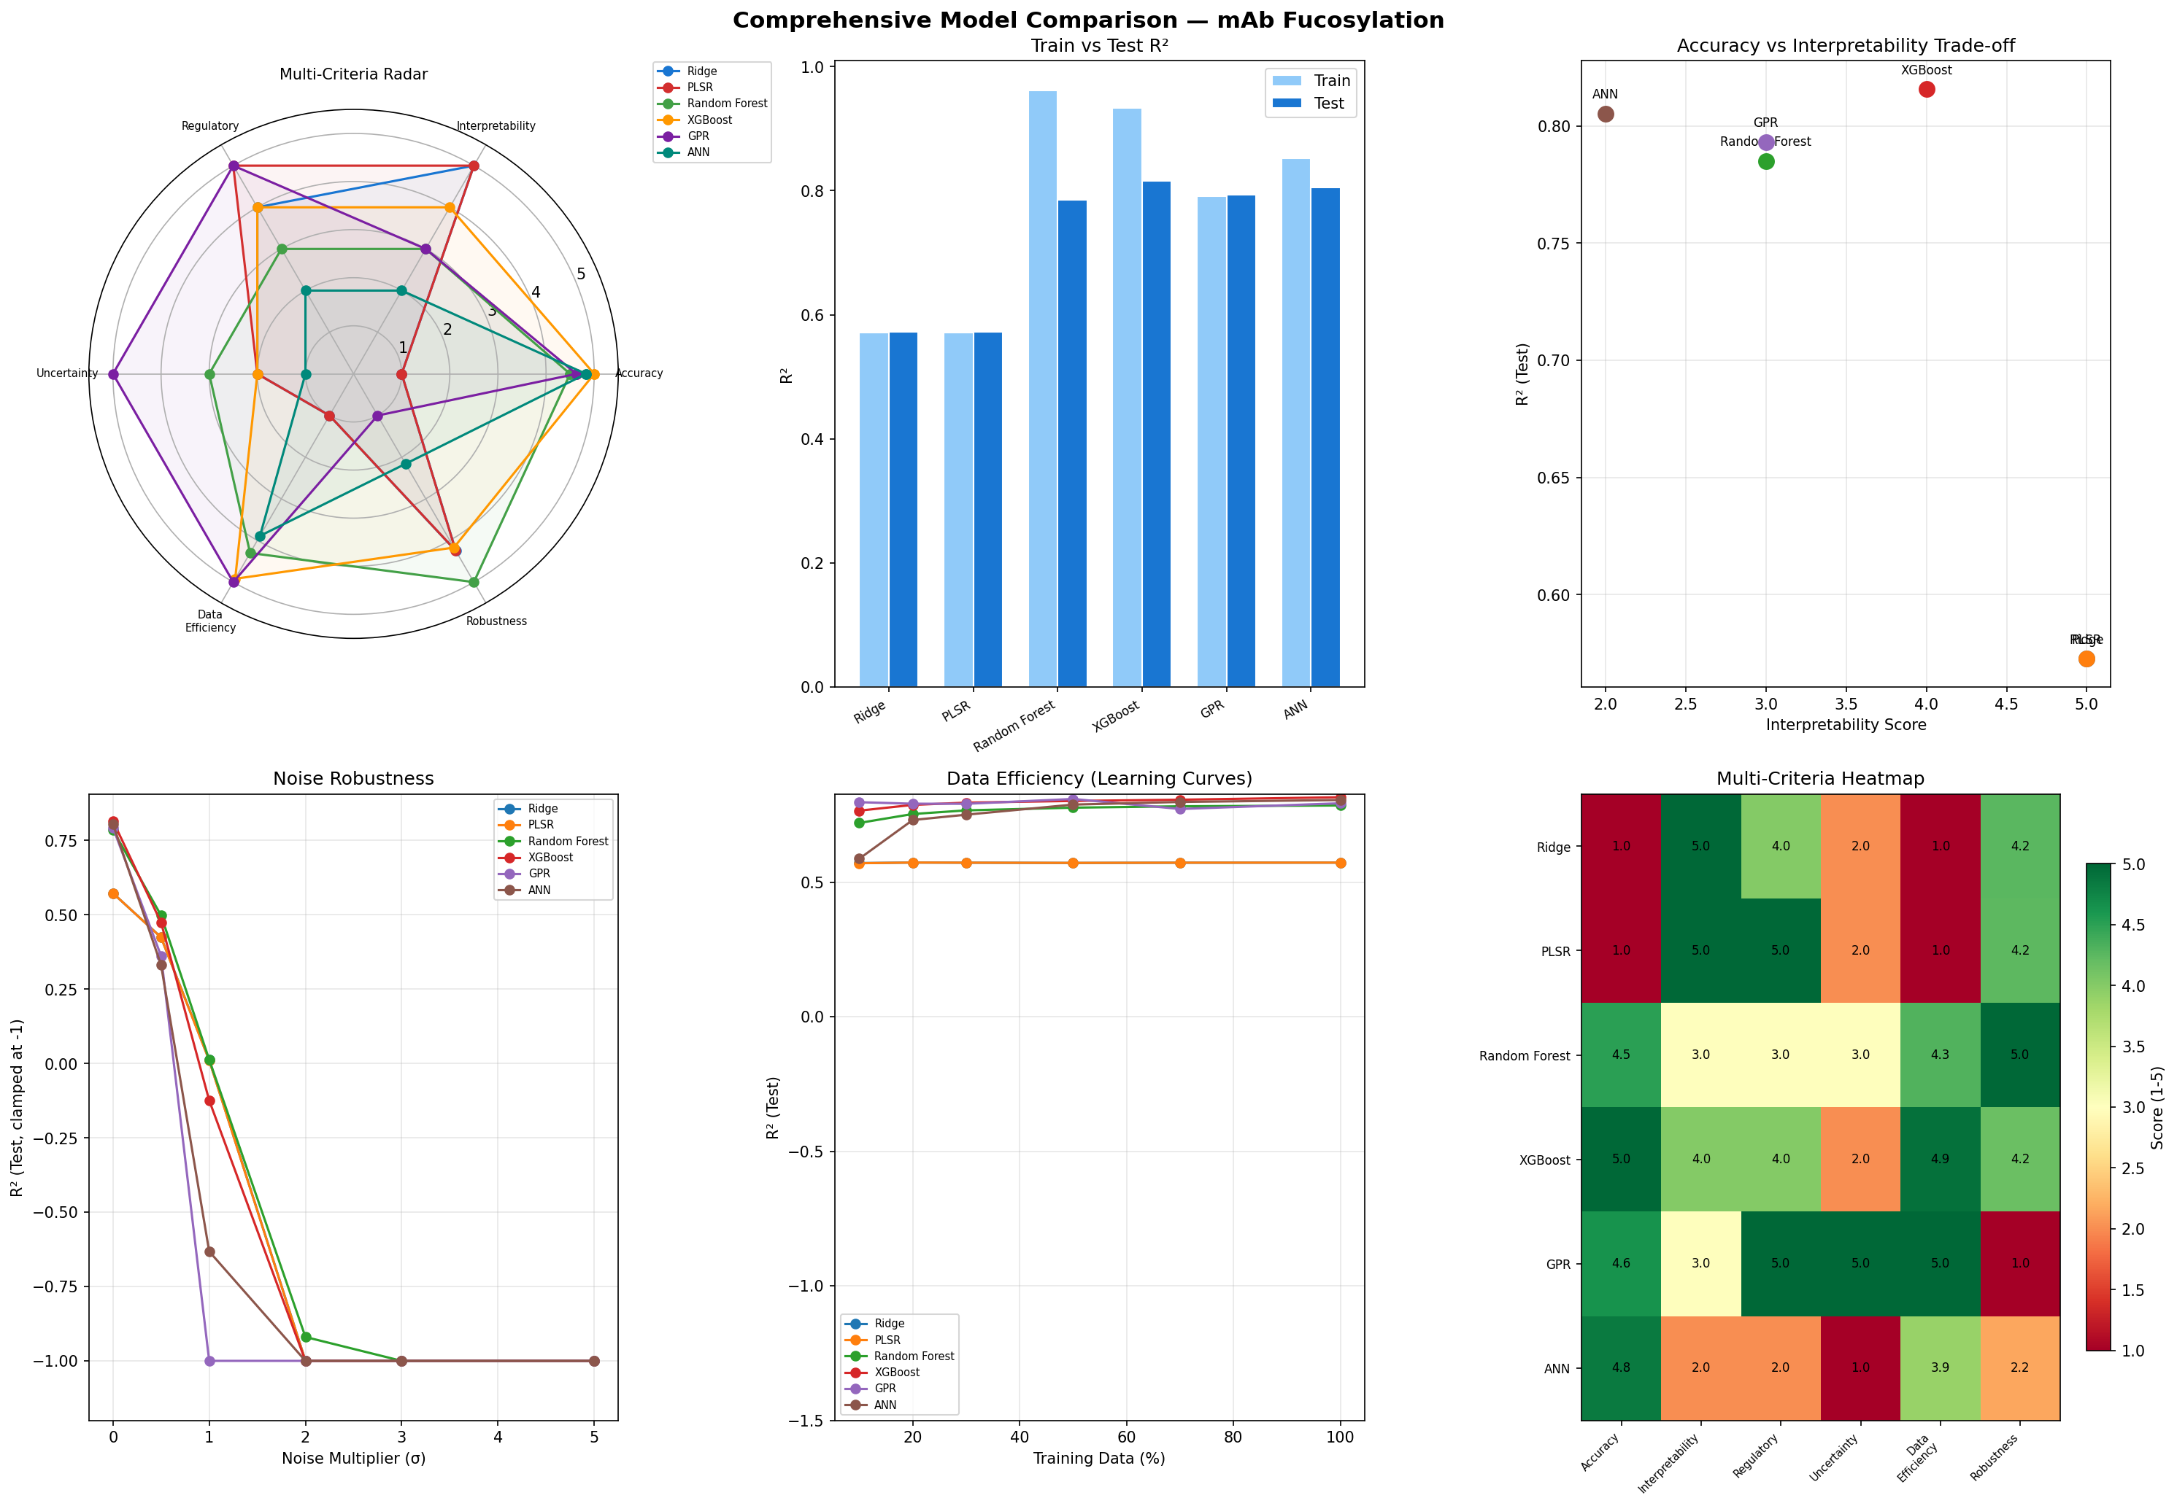
Figure 2: BMS2 (N=10,000) — Radar chart, R² comparison, noise robustness, learning curves, rubric heatmap.

5. Cross-Experiment Comparison

5.1 R² Improvement: N=500 vs N=10,000
Model | R² (N=500) | R² (N=10k) | Abs Change | % Change | Interpretation
Ridge | 0.51 | 0.57 | +0.06 | +12% | Structural limit
PLSR | 0.51 | 0.57 | +0.06 | +12% | Structural limit
RF | 0.66 | 0.79 | +0.13 | +20% | Better splits
XGBoost | 0.74 | 0.83 | +0.09 | +12% | More boosting signal
GPR | 0.75 | 0.79 | +0.04 | +5% | Strong kernel prior
ANN | 0.05 | 0.77 | +0.72 | +1440% | Data hunger resolved

5.2 ANN: Before vs After
The ANN transformation is the headline finding. At N=500, predictions are essentially random. At N=10,000, it becomes competitive with tree-based methods.
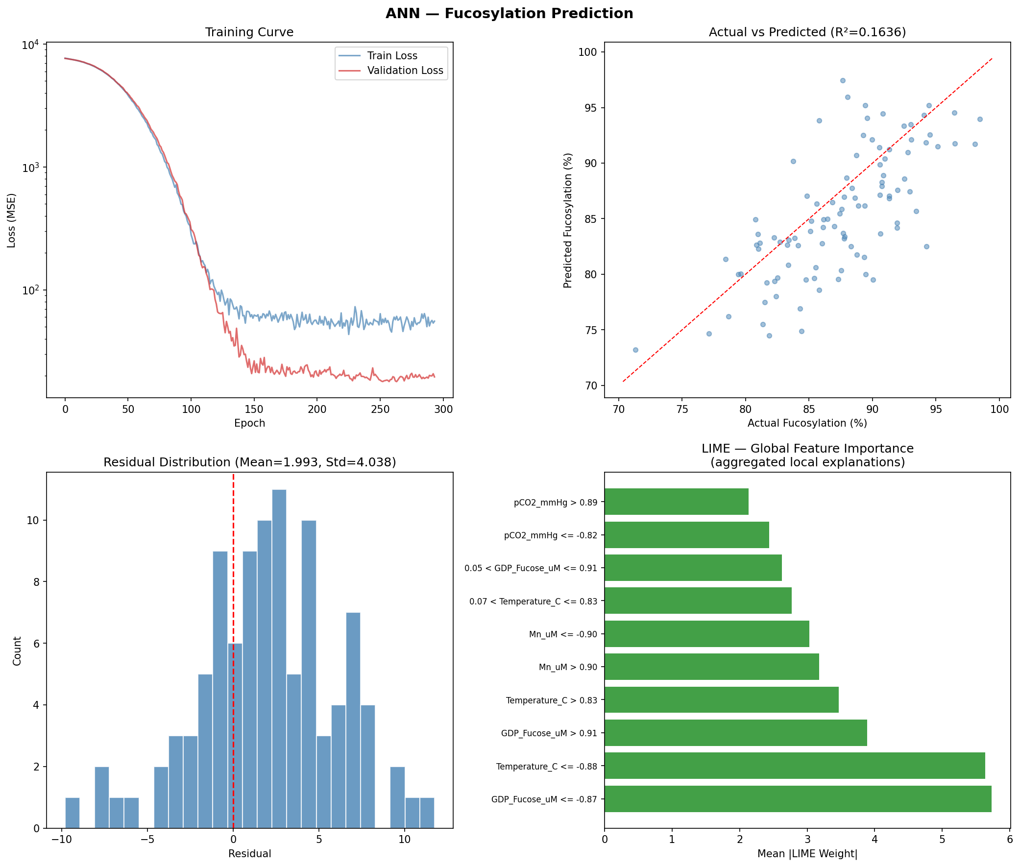
Figure 3a: ANN at N=500 — R²=0.05, scattered predictions, no pattern.
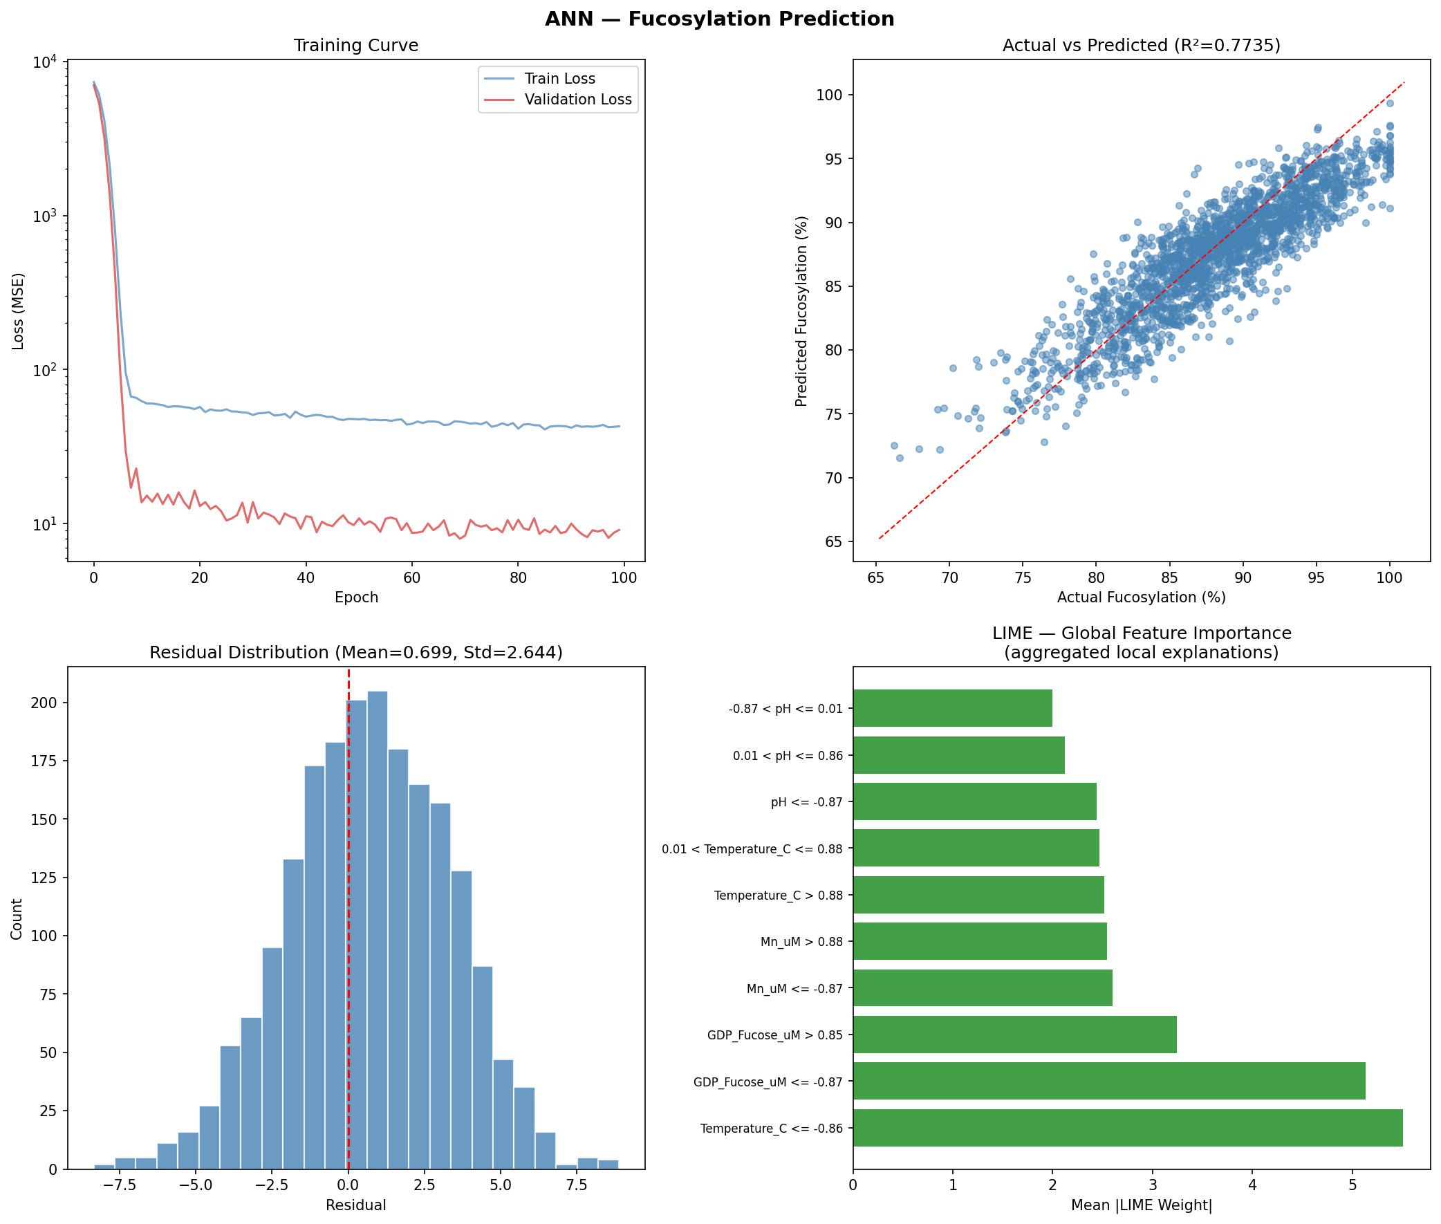
Figure 3b: ANN at N=10,000 — R²=0.77, tight prediction band, meaningful LIME attributions.

5.3 Key Insights
1. Linear models (Ridge, PLSR) hit a structural ceiling. Their limitation is architectural — they cannot capture nonlinear relationships regardless of data volume.

2. Tree-based models are robust across data regimes. XGBoost and RF worked well at N=500 and improved moderately at N=10,000. Their built-in structure provides enough inductive bias to learn from limited data.

3. GPR benefits from strong priors, not data volume. GPR was the best model at N=500 and barely changed at N=10,000 because it is trained on a fixed 300-sample subsample. The RBF kernel encodes the right structural assumption.

4. ANN requires large datasets — period. With 12,225 parameters and no structural prior, the ANN needs thousands of samples to learn what other models get from their architecture. At N=500, it has 36x more parameters than data.

5. XGBoost + SHAP is the best production model. Across both experiments, it consistently delivered top accuracy with full explainability. Recommended for deployment.

5.4 Final Rankings
Category | Best at N=500 | Best at N=10k | Recommendation
Best Accuracy | GPR (0.75) | XGBoost (0.83) | XGBoost + SHAP
Best Uncertainty | GPR | GPR | GPR
Best Interpretability | PLSR / Ridge | PLSR / Ridge | PLSR (academic)
Most Data-Sensitive | ANN (failed) | ANN (recovered) | Avoid for small N
Best Domain Insight | Hybrid | Hybrid | Hybrid features

6. Next Steps
1. Write the final report linking each model to published literature.
2. Prepare presentation slides highlighting the ANN data efficiency finding.
3. Add discussion on industrial relevance: pharma datasets are typically N<1000.
4. Include regulatory considerations (ICH Q8/Q9) for each model type.

— End of Progress Document —

